UNION INTERNATIONALE DE FUTNET (UNIF)

Laws of Futnet

(valid from January 1, 2013)

Contents:

I. Futnet categories and disciplines
0. Categories and disciplines
II. Part of the laws common to all categories and disciplines
1. Playing court and playing area
2. Net
3. Ball
4. Start of play
5. Service
6. Ball in play
7. Scoring a point, winning a set and a match
8. Time-out and player substitution
9. Faults resulting in loss of a point
10. Misconduct and sanctions
11. Player’s equipment and protests
12. Miscellaneous

III. Special characteristics: single
spec. 1. Playing court and playing area
spec. 5. Service
spec. 6. Ball in play
spec. 8. Time-out and player substitution

IV. Special characteristics: double
spec. 1. Playing court and playing area
spec. 5. Service
spec. 6. Ball in play
spec. 8. Time-out and player substitution

V. Special characteristics: triple
spec. 1. Playing court and playing area
spec. 5. Service
spec. 6. Ball in play
spec. 8. Time-out and player substitution

VI. Enclosure to the Laws of Futnet
13. Referees
I. Futnet categories and disciplines:
0. Categories and disciplines

0.1 Categories:
a) Men
b) Women
c) Boys and girls:
- Juniors: age between 16 and 21
- Youngsters: age between 13 and 15
- Children: age up to 12

0.2 Disciplines:
a) Single
b) Double
c) Triple
II. Part of the laws common to all categories and disciplines
1. Playing court and playing area

1.1 Dimensions of the UNIF playing court (located in the centre of the playing area)
a) for single and double: 9.0 m x 12.8 m
b) for triple: 9.0 m x 18.0 m
Every member futnet association can decide (according to the proposal of its Technical Commission) upon the dimensions of the court in all its internal competitions.

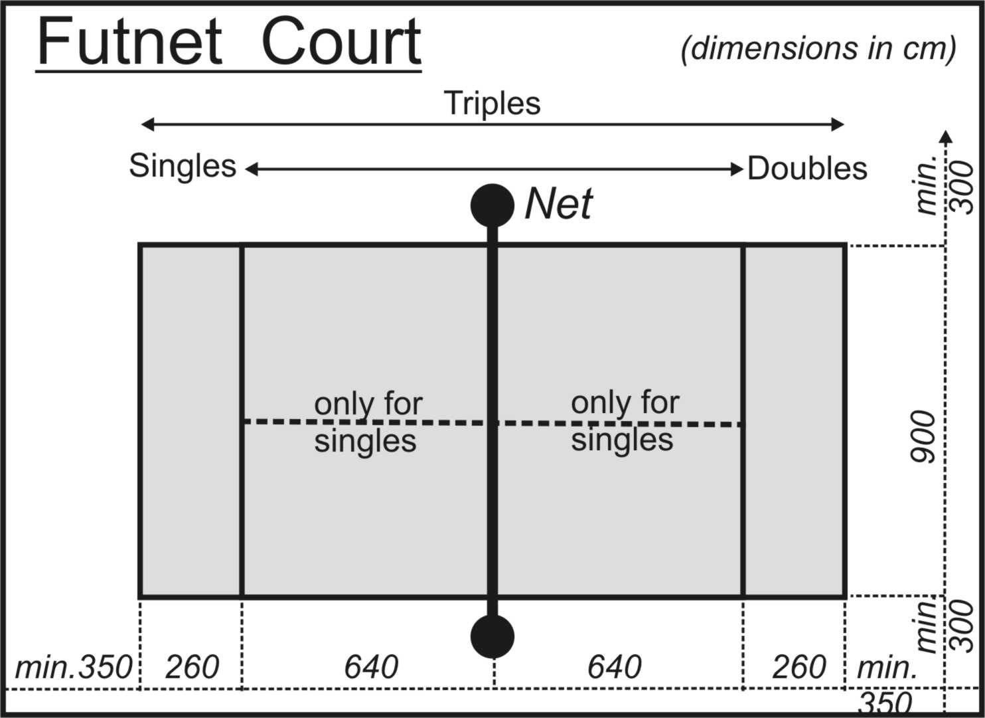

1.2 The playing court is split into two halves by a net.

1.3 Base and side lines are part of the playing court. The lines are 5 cm ± 1 cm thick. The accuracy of the dimension given is ± 5 cm.

1.4 The playing area, which shall be available during the play, has minimum dimensions 15.0 m x 25.0 m. A permissible deviation of the playing area from horizontal level is 1:100. Maximum unevenness of 2 cm without a sharp transition is permissible. The minimum height of free space above the playing area is 8 meters.

1.5 The surface of the playing court and playing area should be homogeneous, must not be slippery, dusty or sinking. The allowed materials for the top surface of playing court and playing area are: clay, grass, wood, usual artificial materials. Not allowed materials for the top surface are: concrete, stone, pavement, asphalt, sand.

2. Net

2.1 Definition: only that part that is hung up over the playing court between the side lines. The length of the net may be defined by two straight round poles of metal or plastic, which support the net on the lines. The poles are part of the net.

2.2 The net is tensioned at both ends so that its top part extends 110 cm over the playing court surface all the way across the playing court. The maximum permissible height deviation of the net is ± 2 cm. The distance between the lowermost edge of the net and the playing court surface is not more than 20 cm.

2.3 The height of the net for Children up to 12 is 100 cm.
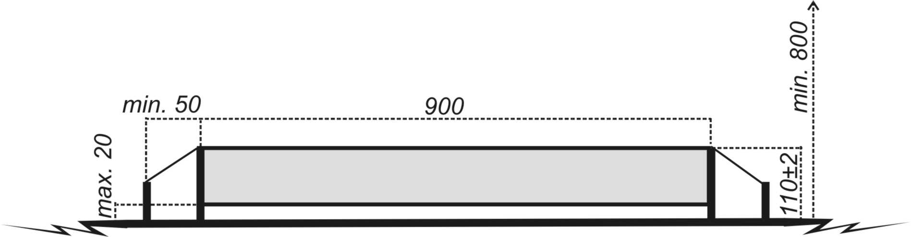

3. Ball

3.1 Official UNIF-ball parameters:
construction: glued, 32 panels, recommended colour: black and white, material: synthetic (natural) leather, weight: 396-453 g, circumference: 680-710 mm, height of rebound: 660-720 mm, inflation: 60-65 kPa. The height of rebound is measured on the Kistler plate by having the ball fall from a height of one (1) metre with the valve facing up.

3.2 A lighter ball of the weight 338–395 g must be used for Children’s category (age up to 12 years).

4. Start of play

4.1 The team (player) who wins the toss has the option to choose either the side or decides, which team starts with the service. In the second set both teams (players) exchange their sides and the first service.

4.2 In case of drawn sets before the third set it is the option of that team (player) to choose the side or the service that - after adding up obtained points - possesses higher number of winning points. Only in case of equal number of winning points the toss is carried out.

4.3 When either team (player) in the third set wins the sixth point, both teams (players) exchange their sides. This is not applied in case of the shortened set (see Law 7.3).

4.4. If not stated otherwise by the Technical Commission of UNIF, the time limits are:
- time for serving after referee´s whistle: 5 seconds
- time for substitution: 30 seconds
- breaks between sets: one minute
- breaks between matches: five minutes (The match is scratched if the team is not present in time at the playing court.)

5. Service

5.1 A service is executed by kicking the ball by any part of the body, except for arm and hand, from the zone behind the base-line, outside the playing court.

5.2 The way of serving: kicking the ball by any allowed part of the body on the volley, after ball rebound, drop-kick or right from the ground. Neither the ball nor the foot shall touch the playing court (including the lines) when a service is being executed. The ball shall be released from serviceman’s hand(s) or lay on the ground for servicing.

5.3 The service shall be carried out within 5 seconds from the moment the referee gives the order to start the play.

5.4 The ball shall cross the net and land on the opponent’s service zone or touch the opponent(s).

5.5 The service is valid even if the ball touches the net and then lands on the opponent’s service zone or touches the opponent(s).

5.6 The service is always carried out by the team (player) who scores a point.

5.7 The opponent is allowed to touch the ball before it has touched his/her service zone.

6. Ball in play

6.1 The maximum number of ball drops on the ground in the UNIF competitions is different for different categories and disciplines (see special characteristics). During the play, the player does not have to let the ball drop down onto the ground.
Every member futnet association can decide (according to the proposal of its Technical Commission) upon the maximum number of ball drops for each category and discipline in respective competitions ruled by the association. The maximum possible number of ball drops in competitions ruled by national futnet association is three (3) for any category and discipline. Between two ball drops (if allowed) there must be always one touch of the player.

6.2 The maximum number of ball touches by the player (single) or team (double, triple) in the UNIF competitions are in single: two (2), in double: three (3), in triple three (3). The player may touch the ball with any part of his/her body except for arm and hand. With the exception of singles, the player is not allowed to touch the ball twice in succession. The minimum number of touches of the ball by player before the ball crosses the net is one (1).
Every member futnet association can decide (according to the proposal of its Technical Commission) upon the maximum number of ball touches by the player or team for each category and discipline in respective competitions ruled by the association.

6.3 If played correctly by the player, the ball shall touch the ground in the playing court only.

6.4 The service is repeated (”new ball”), if a foreign object touches the ball, any player or the playing court or disturbs the play in another way.

6.5 None of the players is allowed to touch the net.

6.6 The ball is played correctly, only if it crosses the net to land into the opponent’s playing court.

6.7 If two opposing players touch the ball over the net at the same time (”dead ball”) and the ball ends out of the playing court, the service is repeated.

6.8 If two opposing players touch the ball over the net at the same time (”dead ball”), the play continues provided that the ball touches the ground within the playing court. In such a case, however, the ball may be played also by the player who played the dead ball.

6.9 The player may play the ball over the opponent’s part of the playing court, if standing or taking off and then landing in his/her own playing court.

6.10 The player may play the ball in his/her opponent´s half of the playing area only above the net.

6.11 The player may unintentionally touch the opponent’s leg (its part under the knee) by his/her leg (its part under the knee).

7. Scoring a point, winning a set and a match

7.1 The team (player) wins a point if the opponent commits a fault, each such a fault being one point.

7.2 All the disciplines (single, double and triple) are played up to two (2) winning sets. A set is won by the team (player), who first scores eleven (11) points with a minimum difference of two (2) points (e.g. 11:9). Otherwise the play is continued until the difference of two points is achieved (12:10, 13:11, etc.). If not, the set is finished, when one of the teams achieves the fifteenth (15th) point (then, the final score of the set is 15:14).
7.3 An alternative scoring method in the third set is the shortened set (“tie-break”). In that case the team (player) which first achieves the seventh (7th) point will win the set and the match – no two-point difference is necessary. The use of tie-breaks must be announced before the event. However tie-breaks must not be used in knock-out stage matches.

8. Time-out and player substitution

8.1 Both a coach and a captain have the right to ask a referee for a 30-second-long time-out (see Special characteristics).

8.2 Each team is entitled - except for single - to substitute players twice per set.

8.3 The referee is entitled at any time in the course of the set to declare ”referee’s time-out” to remove obstacles of any nature.

8.4 During the break and time-outs, the players shall stay out of the playing court in playing area or near the bench.

9. Player´s faults resulting in loss of point

9.1 The ball touches the court twice in sequence without being touched by any player.

9.2 The ball bounces off the player´s half, crosses the net to the opponent’s court and is not touched by the player.

9.3 A player touches the net by any part of his/her body.

9.4 A player has made one of the following faults when the ball is being served:
a) he/she touches either the court (incl. base line) or a side line extended backwards with the ball or with his/her foot at the moment when he/she is touching the ball,
b) the ball being served and flying to the opponent’s court is touched by his/her co-player,
c) the ball lands outside the service zone on the opponent’s court.

9.5 A player touches the ball with his/her hand or arm.

9.6 The ball played by a player flies to the opponent outside the net.

9.7 The ball played by a player lands outside the opponent’s playing court.

9.8 The ball is played by a player over the opponent’s playing court and the player does not stand or takes off and does not land within his/her own court.

9.9 If the ball touches any foreign object, it is a fault made by the player who touched the ball as the last.

9.10 A player holds or pushes his/her opponent with his/her hand(s).

9.11 A player plays the ball twice in sequence (applies to doubles and triples).

9.12 A player plays the ball on the opponent’s half of the playing area outside the net.

9.13 The player touches the ball bounced off the opponent´s court surface before the opponent touches it (a loss of point of the opponent).

9.14 A player touches an opponent player (with the exception of Law 6.11) with his/her leg.

10. Misconduct and sanctions

10.1 If a player exceeds intentionally any time limit, he/she is sanctioned:
- after first delay with warning (without loss of point)
- after second delay with yellow card (loss of point).

10.2 Unsportsmanlike conduct (protests, claims, deliberate playing the ball to hit the referee, kicking the ball away, delaying the play, holding and pushing the opponent, abusive language, improper gesturing etc.) by players, coaches, team leaders is sanctioned:
- for the first time with warning (without loss of point) or with yellow or red card (loss of point)
- for the second time with yellow or red card (loss of point).

10.3 After being sanctioned by yellow card player’s next misconduct is sanctioned by red card (expulsion and loss of point). After receiving the red card the player must immediately leave the playing area.

10.4 An expelled player may be substituted in doubles and triples by another player and it does not count as a substitution. In singles, the opponent wins the match 2:0 (11:0, 11:0) by default and all expelled player´s matches are scratched in the same way. When the player in double or triple is injured in such a way that he/she cannot continue to play and his/her team has no more substitution to utilize, the set is scratched in favour of the opponent team.

10.5 If the referee is insulted by player(s) or member(s) of the official delegation the match is scratched in favour of the opponent team.

11. Player’s equipment and protests

11.1 Players of one team shall use uniform playing suits with numbers from 1 to 99; if not they are not allowed to play by the referee.

11.2 When the play is interrupted, the team captain or coach has the right to raise hand to deliver their protest(s) to the referee and ask a question about the interpretation of the laws. The consecutive referee’s decision is final.

11.3 Protests, if any, are dealt with in compliance with the competition schedule, when the match is over. A final decision is up to UNIF jury created for the competition.

12. Miscellaneous

12.1 Other disputable issues are dealt with by the respective control authority of the UNIF competitions.

12.2 In the year of a championship only the player, who achieved the right age (including lowermost and uppermost age limit) stated for his/her category, is allowed to take part in the championship. Younger players are allowed to start in upper category only with written physician´s permission or with the declaration of honour signed by the head of delegation.
12.3 Children are allowed to play in not more than two disciplines during one UNIF event (championship, tournament).
12.4. It is forbidden to start simultaneously in two age or gender categories if their competitions are held at the same time.
12.5. Official interpretation of any paragraph of the Laws of Futnet belongs only to the UNIF Technical Committee.
III. Special characteristics: Single
spec. 1. Playing court and playing area

1.1 One half of the playing court is 9.0 m x 6.40 m in dimensions. Both halves of the playing court are divided by a middle line into two service zones of the same size 4.5 m x 6.40 m.

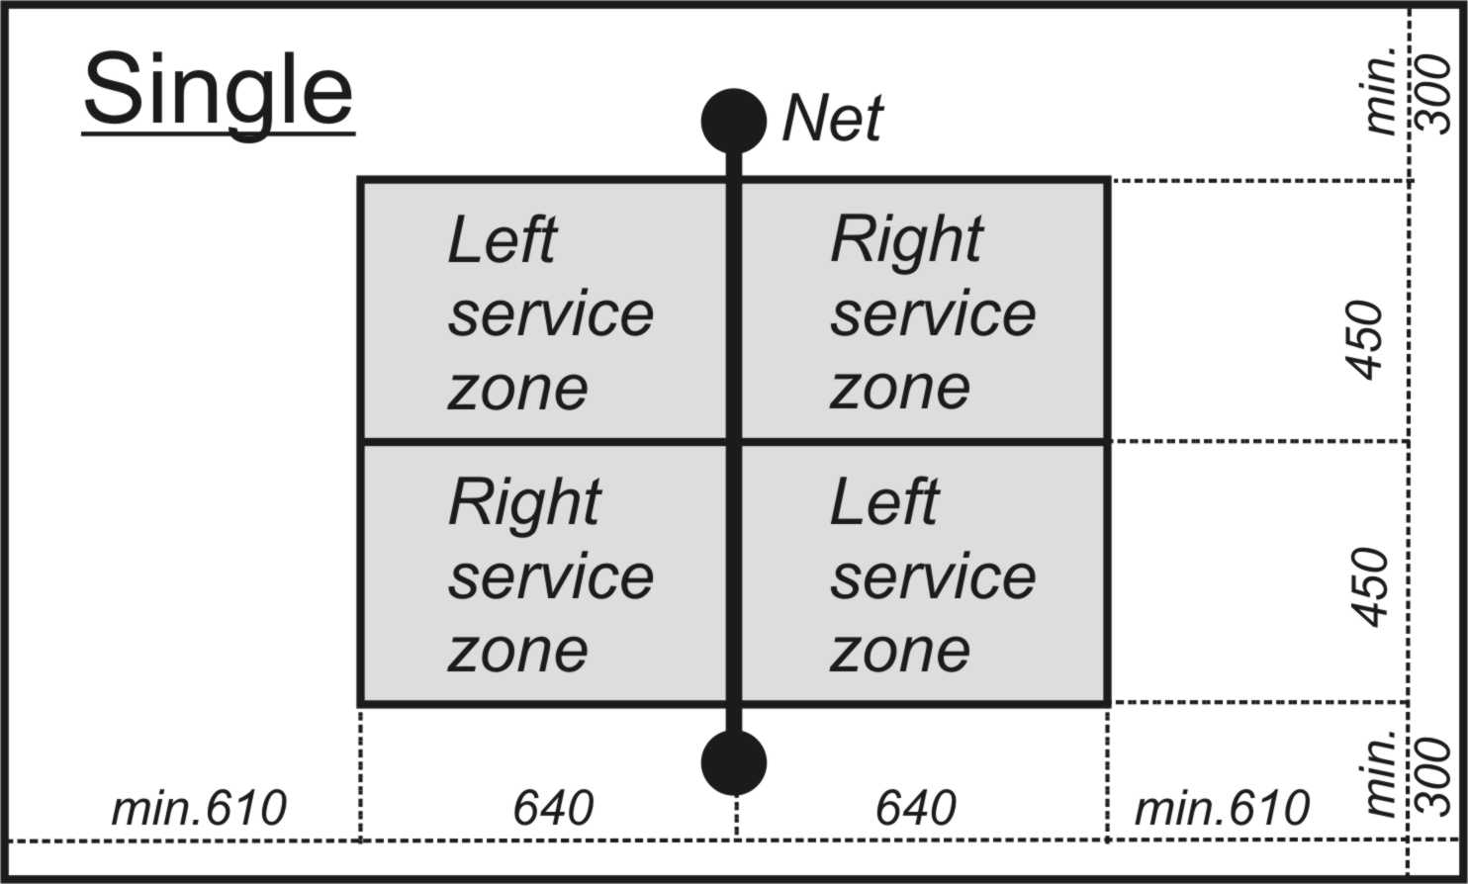

spec. 5. Service

5.1 A service may be executed only from the space behind the base line, between the middle and side lines. A service shall be executed diagonally from the right or left, depending on the own number of points scored: from the right, if the number is even (0:0, 2:1, 4:6, etc.), from the left if the number is odd (1:0, 1:1, 1:2, 3:2, etc.). If lands, the ball must land in the opponent’s diagonal service zone.

spec. 6. Ball in play

  - The maximum number of ball drops on the ground in the UNIF competitions:
one (1) for men, women, juniors, youngsters
two (2) for children up to 12

6.2 The maximum number of ball touches by the player in the UNIF competitions:
two (2) for men, women, juniors, youngsters, children up to 12
The player may touch the ball twice in sequence before the ball crosses the net.

spec. 8. Time-out and player substitution

8.1 Each player is entitled to two (2) 30-second time-outs per set after the coach or the captain has requested that from the referee. In case of the shortened 3rd set (“tie-break”) each player has only one (1) time-out.

8.2 No player substitution is allowed.
IV. Special characteristics: Double
spec. 1. Playing court and playing area

1.1 One half of the playing court is 9.0 m x 6.40 m in dimensions. The service zone has the same dimensions. None of the two service zones is divided.

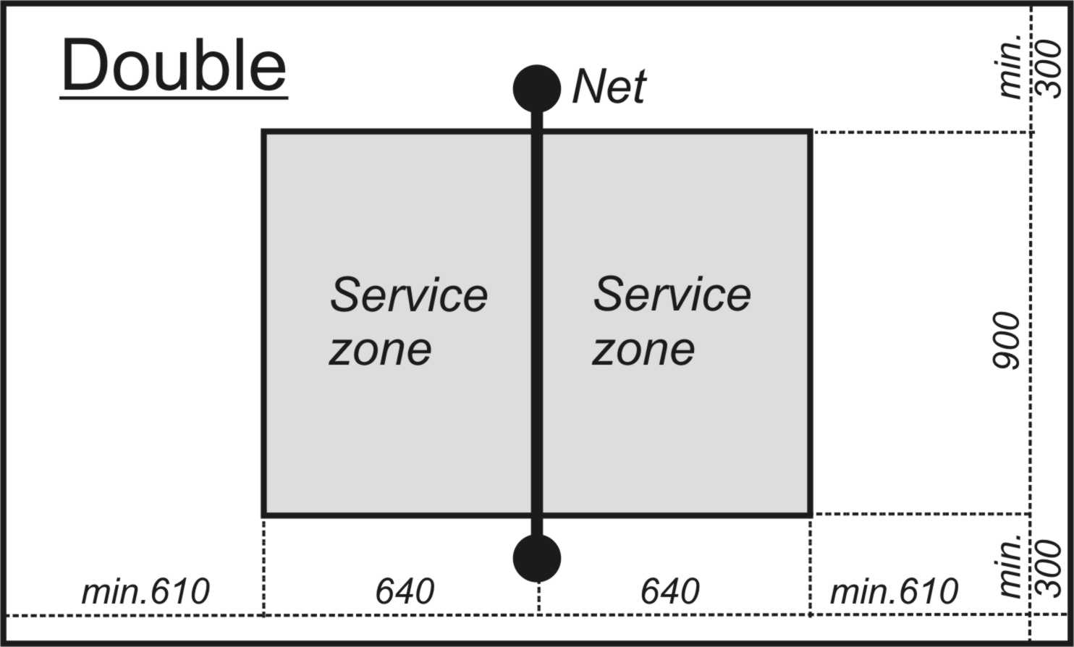

spec. 5. Service

5.1 A service may be executed only from the space behind the base line, between the side lines, by any player serving the ball into the opponent’s service zone.

spec. 6. Ball in play

6.1 The maximum number of ball drops on the ground in the UNIF competitions:
one (1) for men
two (2) for women, juniors, youngsters
three (3) for children up to 12

6.2 The maximum number of ball touches by the player in the UNIF competitions:
three (3) for men, women, juniors, youngsters, children up to 12
The ball shall not be touched twice in succession by the same player.

spec. 8. Time-out and player substitution

8.1 Each double is entitled to one (1) 30-second time-out per set, after the coach or the captain has requested that from the referee.

8.2 Each double consists of three (3) players of whom two (2) shall be always playing and one (1) is their substitute. Each double is entitled to substitute one (1) of the players twice per set.
V. Special characteristics: Triple
spec. 1. Playing court and playing area

1.1 One half of the playing court is 9.0 m x 9.0 m in dimensions. The service zone is 9.0 m x 6.40 m in dimensions. None of the two service zones is divided.

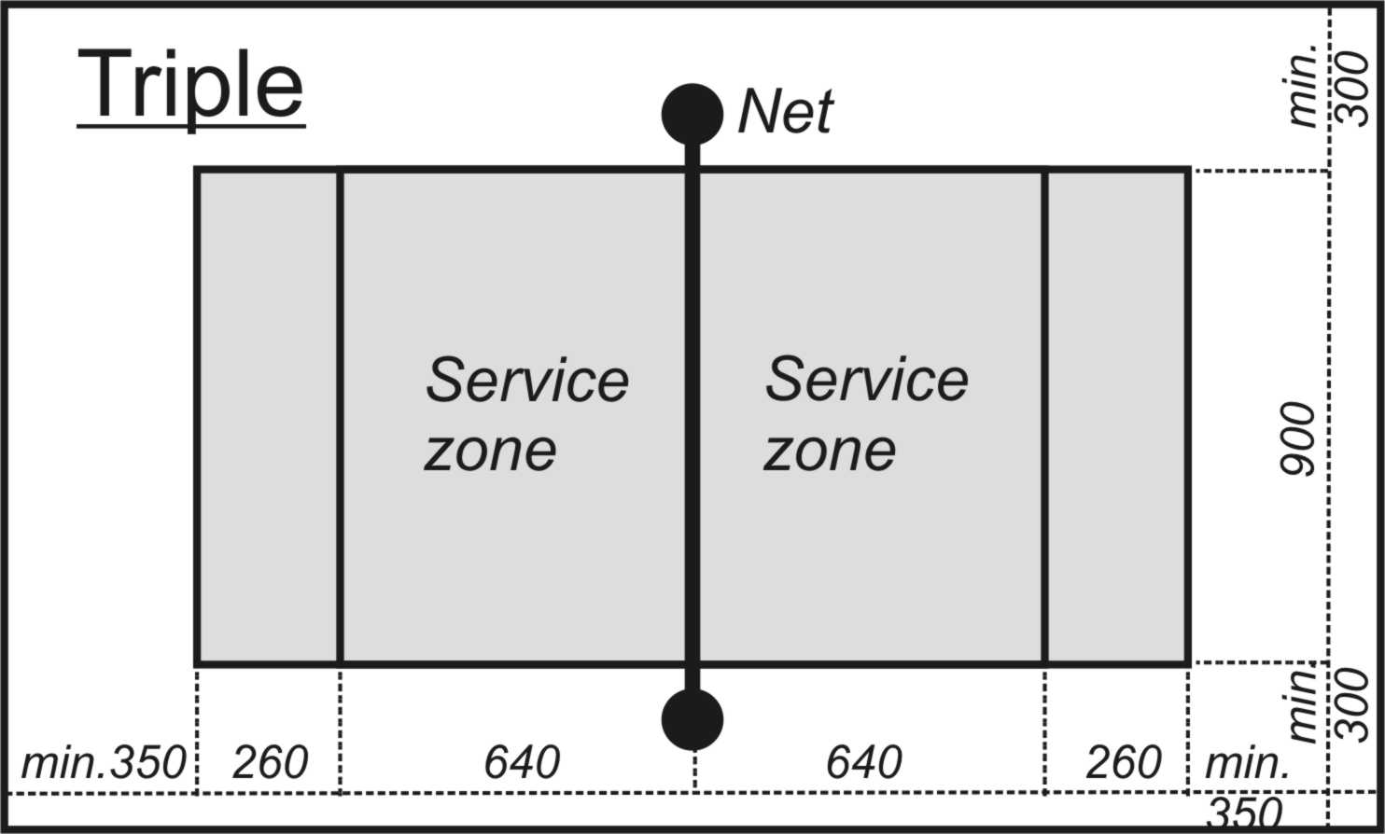

spec. 5. Service

5.1 A service may be executed only from the space behind the base line, between the side lines, by any player serving the ball into the opponent’s service zone.

spec. 6. Ball in play

6.1 The maximum number of ball drops on the ground in the UNIF competitions:
one (1) for men
two (2) for women, juniors, youngsters
three (3) for children up to 12

6.2 The maximum number of ball touches by the player in the UNIF competitions:
three (3) for men, women, juniors, youngsters, children up to 12
The ball shall not be touched twice in succession by the same player.

spec. 8. Time-out and player substitution

8.1 Each triple is entitled to one (1) 30-second time-out per set, after the coach or the captain has requested that from the referee.

8.2 Each triple consists of five (5) players of whom three (3) shall be always playing and two (2) are their substitutes. Player substitution can be carried out twice per set, one (1) or two (2) players can be substituted in one (1) substitution.
VI. Enclosure to the Laws of Futnet
13. Referees

13.1 Number of referees: The match is arbitrated by two referees (first referee, second referee). Another number of referees can be stated by UNIF Technical Committee controlling the competition. The support by line referees is welcome.

13.2 Rights of both referees: All members of the team (players, coach, team leader, etc.) in the playing area are obliged to keep the instructions of referees.

13.3 Shared duties of both referees:
a) make opening toss,
b) give instructions for interruption of the play,
c) judge the faults in play and decide (arbitrate) which team receives a point,

d) control the score of the match,
e) give instructions to arrange dress, lines, playing area etc.,
f) judge the players’ and others’ behaviour and give them penalties,

g) measure and keep time limits,
h) use a whistle and official signals,

i) arbitrate the match according to the Laws of Futnet valid in time of the competition.

13.4 Complementary duties of the first referee:
a) give instructions for start of the play,
b) may order a new ball having different judgement with the second referee on fault that has happened or when needed,
c) permit and control the substitutions of players and time-outs
d) decide if current conditions (weather, visibility, etc.) for the game are satisfied,
e) decide which.shared duties will be performed only by him/her.

13.5 Complementary duties of the second referee:
a) decide if technical conditions (size of the playing court, ball, net, lines etc.) are OK for start of the play,
b) fill in or control filling in the match record,
c) control the number of substitutions and time-outs
d) adhere to instructions of the first referee except judgement about faults in the play.

13.6 Standing point of referees: The referees should stand close to the post (pole) on both sides of the net or sit on the umpire´s chair.

13.7 The referees have to use uniform suits.
  - Referee official signals:
Futnet situation | Signal/Action
New ball (new service) | Extend arms sideways and raise the thumbs of both fists
Time-out | Place the palm of one hand over the other hand vertically, forming the letter “T”. Indicate the team requesting the time-out
Second drop | Point with two fingers downwards
Third drop | Point with three fingers downwards
Double touch | Raise one arm vertically with two extended fingers and point at the faulty player with the other arm
Service fault | Point at the base line with one hand and move the palm of the other hand behind it (like drawing the line)
Player(s) substitution | Make a circular motion of open hands (one around the other) above the head
Net touch | Touch the net with one hand and point at the faulty player with the other hand
Hand touch | Extend one arm and tap its wrist with the other hand
Keep playing! (only informatory) | Extend arms sideways with open hands
Ball outside the net | Raise one arm above the head and make half-circle around it with the fist of the other hand
Ball “in” (only informatory) | Point with both open hands downwards
Ball “out” | Raise the forearms vertically with open hands, palms towards the face
Interfering foreign object | Stop the play immediately (whistle) and use the “new ball” signal
Foul | Stop the play immediately (whistle), with the fist of one hand hit the palm of the other hand and point at the fouling player
Serve! | Whistle and move the palm of the hand extended forwards in direction from serving to receiving side
Ball touched foreign object | Stop the play (whistle), raise one arm and point upwards
Player´s touch of the ball above the net (only informatory) | Extend one arm sideways and raise the thumb of its fist vertically
--- End of the Laws of Futnet ---

